Java with DSA –Day 13
Insertion Sort
import java.util.*;
class isort{
public static void main(String[] args){
Scanner sc=new Scanner(System.in);
System.out.println("Enter the No of Elemnts..");
int n=sc.nextInt();
int[] arr=new int[n];
System.out.println("Enter the Elemnts..");
for(int i=0;i<n;i++){
arr[i]=sc.nextInt();
}
for(int i=1;i<n;i++){
int key=arr[i];
int j=i-1;
while(j>=0 && arr[j]>key){
arr[j+1]=arr[j];
j--;
}
arr[j+1]=key;
}
System.out.print("Sorted Array: ");
for(int num:arr){
System.out.print(num+" ");
}
}
}

Output:
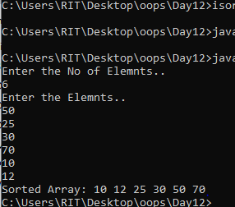

Recursion:
import java.util.*;
class sum{
public static void main(String[] args){
Scanner sc=new Scanner(System.in);
System.out.println("Enter the no of Elements:");
int n=sc.nextInt();
System.out.println("Sum of digits:"+display(n));
}
static int display(int n){
if(n==0){
return 0;
}
return(n%10)+display(n/10);
}
}
Output:
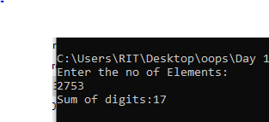

Factorial of given No:
import java.util.*;
class fact{
public static void main(String[] args){
Scanner sc=new Scanner(System.in);
System.out.println("Enter the No: ");
int n=sc.nextInt();
System.out.println("Factorial of "+n+": "+display(n));
}
static int display(int n){
if(n==0 || n==1){
return 1;
}
return n*display(n-1);
}
}
Output:
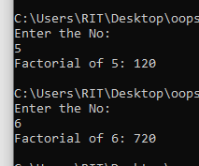
Fibonacci Series:
import java.util.*;
class fibo{
public static void main(String[] args){
Scanner sc=new Scanner(System.in);
System.out.println("Enter the No: ");
int n=sc.nextInt();
System.out.println("Fibonaaci of "+n+": "+display(n));
}
static int display(int n){
if(n<=1){
return n;
}
return display(n-1)+display(n-2);
}
}
Output:
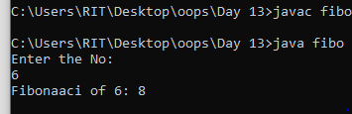

Merge Sort:
import java.util.*;
class merge{
public static void main(String[] args){
Scanner sc=new Scanner(System.in);
int[] arr={40,30,10,70,5,20};
int l=0;
int r=arr.length-1;
sort(arr,l,r);
for(int a : arr){
System.out.println(a);
}
}
static void sort(int[] arr,int l,int r){
if(l>=r){
return;
}
int mid=(l+r)/2;
sort(arr,l,mid);
sort(arr,mid+1,r);
mergesort(arr,l,mid,r);
}
static void mergesort(int[] arr,int l,int mid,int r){
int left=l;
int right=mid+1;
int temp[]=new int[r-l+1];
int index=0;
while(left<=mid && right<=r){
if(arr[left]<=arr[right]){
temp[index++]=arr[left];
left++;
}
else{
temp[index++]=arr[right];
right++;
}
}
while(left<=mid){
temp[index++]=arr[left];
left++;
}
while(right<=r){
temp[index++]=arr[right];
right++;
}
int j=0;
for(int i=l;i<=r;i++){
arr[i]=temp[j++];
}
}
}
Output
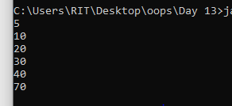

Merge Two Sorted Array:

import java.util.*;
class sort{
public static void main(String[] args){
Scanner sc=new Scanner(System.in);
System.out.println("Enter the no of Elements for array1: ");
int n=sc.nextInt();
int[] arr1=new int[n];
System.out.println("Enter the Elements for array1: ");
for(int i=0;i<n;i++){
arr1[i]=sc.nextInt();
}
System.out.println("Enter the Elements for array2: ");
int k=sc.nextInt();
int[] arr2=new int[k];
System.out.println("Enter the Elements for array2: ");
for(int i=0;i<k;i++){
arr2[i]=sc.nextInt();
}
int[] temp=new int[n+k];
int index=0;
int left=0;
int right=0;
while(left<n && right<k){
if(arr1[left]<=arr2[right]){
temp[index++]=arr1[left];
left++;
}
else{
temp[index++]=arr2[right];
right++;
}
}
while(left<n){
temp[index++]=arr1[left];
left++;
}
while(right<k){
temp[index++]=arr2[right];
right++;
}
for(int a : temp){
System.out.print(a+" ");
}
}
}
Output:
